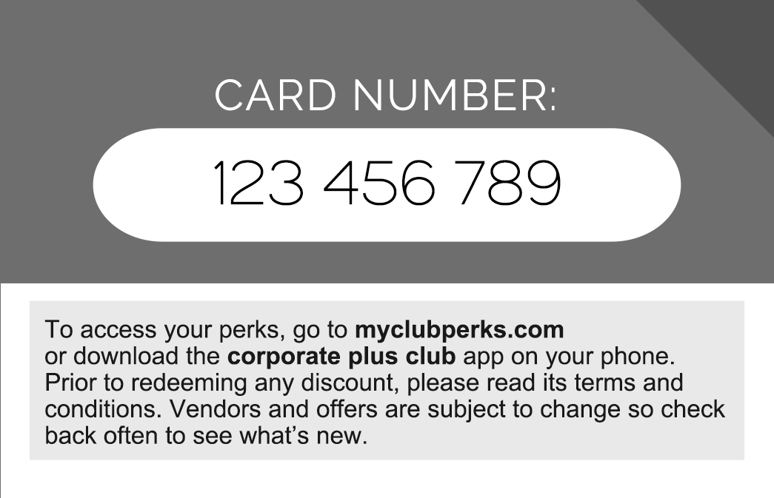
WHEN A CUSTOMER SHOWS YOU THIS CARD, THE FOLLOWING DISCOUNT/OFFER MUST BE HONORED:

__________________________________________________________________________________________________________________________________________________________________________________________________________________________________________________________________________________________________________________________________

