We are growing our local benefits program for our clients and other people in your neighbourhood. By providing an offer to post in their benefits page, you will be advertising and driving more traffic to your business. The posting is free of charge, and we would be happy to provide cards for you and your staff as well. As we refer clients to your business, we ask that you do the same and refer clients to us.
What’s Needed:
- Your Company Information/Logo
- Description of your offer plus any terms & conditions.
- How to redeem the offer (Simply showing the card is recommended)
Benefits
- Exposure to client network
- Build business referrals
- No cost to join
Recommended Offers
- “Special Rate”
- $ or % Off Service/Charge
- Gift or Added Service
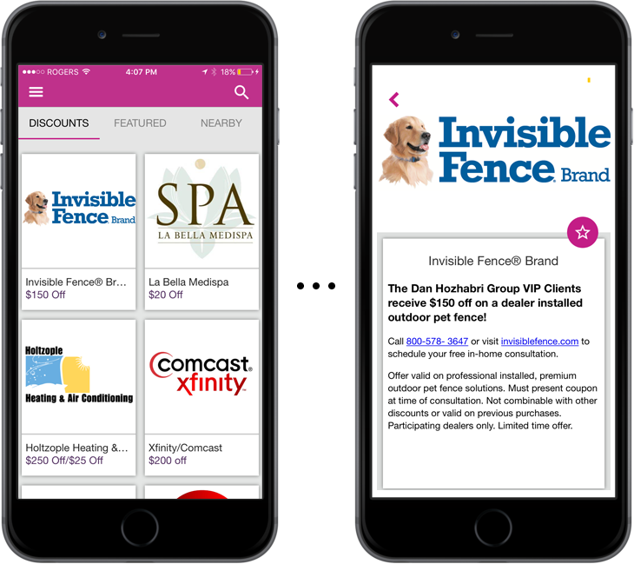

The success of this program is heavily dependent upon our business partners. It is imperative that you and your staff are trained on how to respond when a client contacts your business about redeeming the special you choose to offer. Any negative feedback received could result in the termination of this business agreement and removal of your business from this program.

