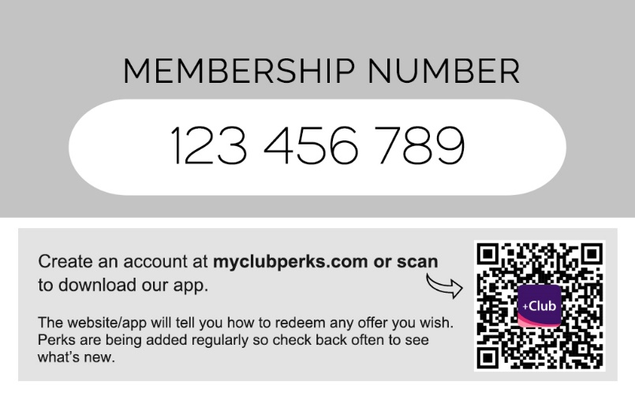

This card gives you access to our custom perks which allows you to save an unlimited amount of money for as long as your membership lasts.

Gain access using your card number at myclubperks.com or download the free corporate plus club app on iPhone or Android.
We continually add new partners and updates, so check back often to see what’s new.

