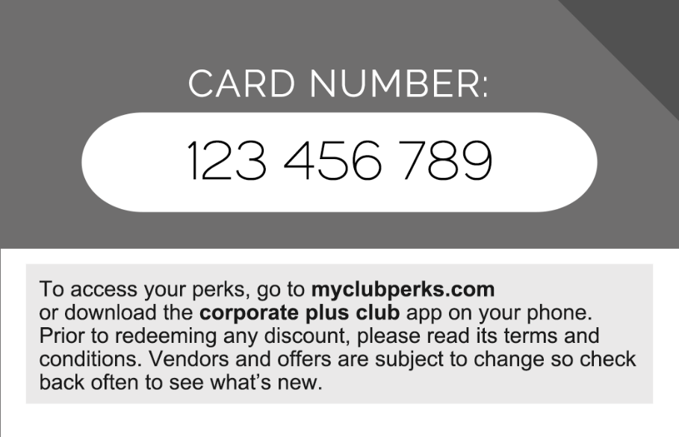

This card gives you access to our custom perks which allows you to save an unlimited amount of money for as long as your membership lasts.

Gain access at myclubperks.com or scan the qr code or download the free “corporate plus club” app on iPhone or Android.
You will have full and free access to your perks at any time, so check back often for new partners and updates.

